Functions https://www.w3schools.com/python/
We can define our own functions in Python and reuse them throughout the program. The syntax for defining a function is as follows:
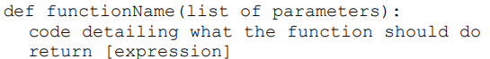
ejemplo
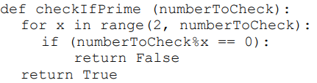
answer = checkIfPrime(13)
Firstly, any variable declared inside a function is only accessible within the function. These are known as local variables. Any variable declared outside a function is known as a global variable and is accessible anywhere in the program. To understand this, try the code below
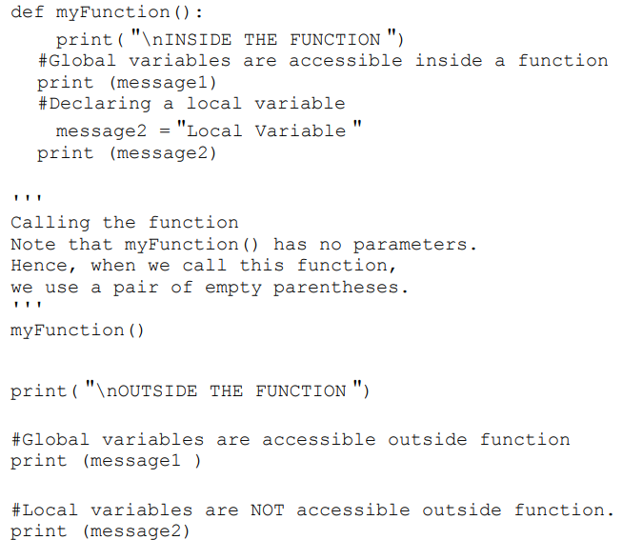
RUN the program
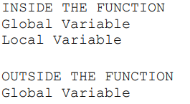
NameError: name 'message2' is not defined
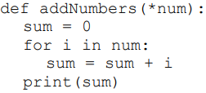
addNumbers(1, 2, 3, 4, 5) -- Reslt 15
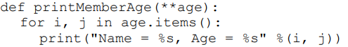 Parameter age
printMemberAge(Peter = 5, John = 7) --Result
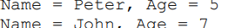

Class
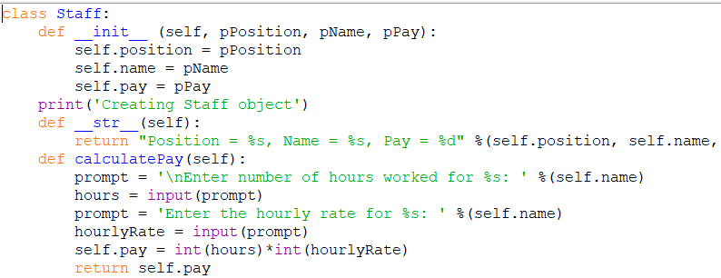
Instance Variables; position name pay Parameters: pPosition pName pPay
Methods: __init__ __str__ calculatePay()
__str__ is another special method return a human readable string that represent a class
officeStaff1 = Staff('Basic', 'Yvonne', 0)
Creating Staff object
officeStaff1.name ‘Yvonne’
officeStaff1.position ‘Basic’
officeStaff1.Pay 0
#change variable position
officeStaff1.position = 'Manager'
#print position again
officeStaff1.position Output: 'Manager '
To use calculatePay() method to calculate pay
officeStaff1.calculatePay()
Output:
Enter number of hours worked for Yvonne: 10
Enter the hourly rate for Yvonne: 15
To print variable pay again officeStaff1.pa y
Output: 150
To print a string representation of
officeStaff1 print(officeStaff1)
Output: Position = Manager, Name = Yvonne, Pay = 150
To prevent such errors from occurring, we can use properties. Properties provide us with a way to check the values of the changes that we want to make before allowing the change to occur.
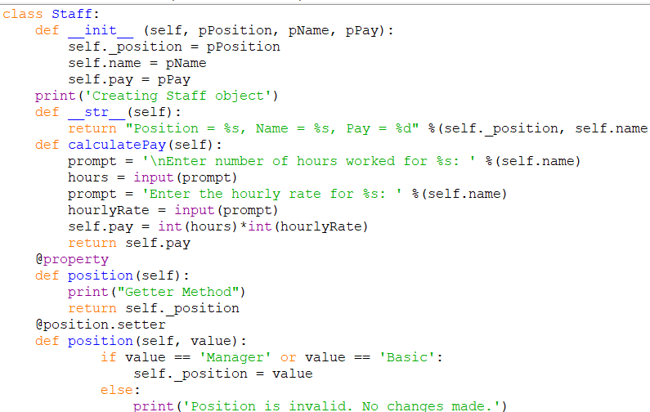
This second position() method is known as a setter method. It has a parameter called value that is assigned to _position as long as value is either 'Manager' or 'Basic' . If value is neither of these, the message ‘Position is invalid. No changes made. ’ is displayed.
officeStaff1 = Staff('Basic', 'Yvonne', 0)

Let’s consider an example. Supposed Peter and John both work for a company called ProgrammingLab. We can create a class called ProgStaff to store this information.
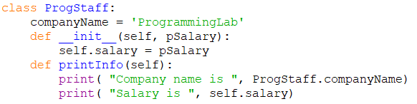
peter = ProgStaff(2500)
john = ProgStaff(2500)
The first few lines of the code above defines a class called ProgStaff . This class has a variable called companyName that is not defined inside any method
Add the following lines to selfdemo.py to verify that.
ProgStaff.companyName = 'ProgrammingSchool'
print(peter.companyName) print(john.companyName )
Notice that in the code above, as we are not typing directly into the Python Shell, we have to use the print() function to display the value of companyName for peter and john . Save the file and run the program. You’ll get the following output:
ProgrammingSchool
ProgrammingSchool
Next, suppose the salary of peter is increased to 2700. We update it as follows: peter.salary = 2700
This change only affects the instance 'peter '. We can verify it by printing the salary of peter and john . Add the following lines to selfdemo.py and run the program:
peter.salary = 2700
print(peter.salary)
print(john. salary) You’ll get 2700 2500
Folder PYTHON FUNCTIONS CLASSES
myfunc1 myfunc5 myfunc6 myfunc7 myfunc8 myfunc9
Cassdemo.py classdemo1 classemo3

class and static methods. methoddemo.py
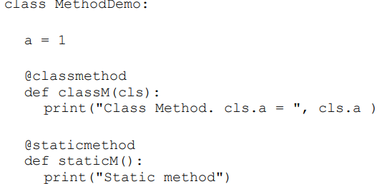
This class has a class variable a and two methods – classM() and staticM() . The first method, classM() , is a class method. To define a class method, we need to use the @classmethod decorator to inform Python that what follows is a class method. A class method is a method that has a class object (instead of self ) as the first parameter. cls is commonly used to represent that class object. cls is sort of similar to self . The main difference is self refers to an instance while cls refers to a class

Importing a class myclass.py
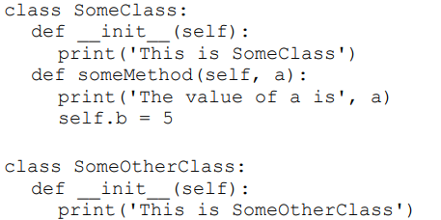
Importdemo.py
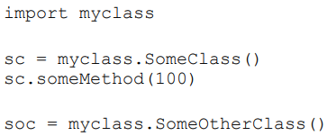 Yu get:
This is SomeClas s The value of a is 100 This is SomeOtherClass

create a sub class. ManagementStaff democlass.py (Adicionado)
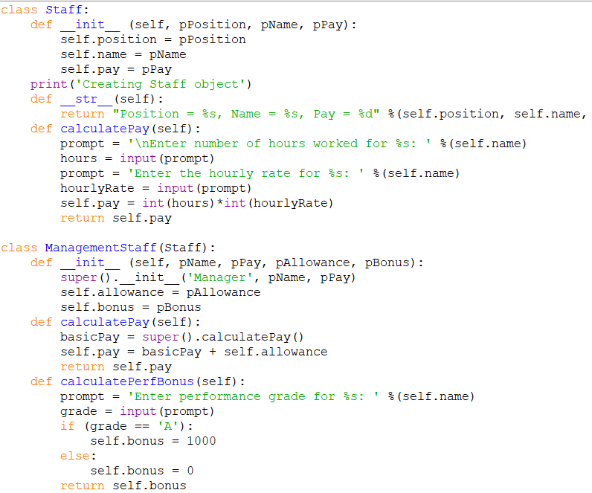

Inheritancedemo.py
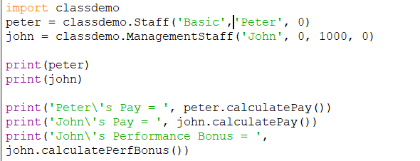
Result
